APPLICATION FOR NEIGHBORHOOD WATCH SIGNS
Once you have your first meeting and have met the participation requirement, complete this form. Once the form has been completed, send it to the law enforcement officer in your community who has been working with you and your group for verification. Once your group has been sanctioned, your Neighborhood Watch sign will be ordered. Neighborhood Watch signs are free of charge to the group.

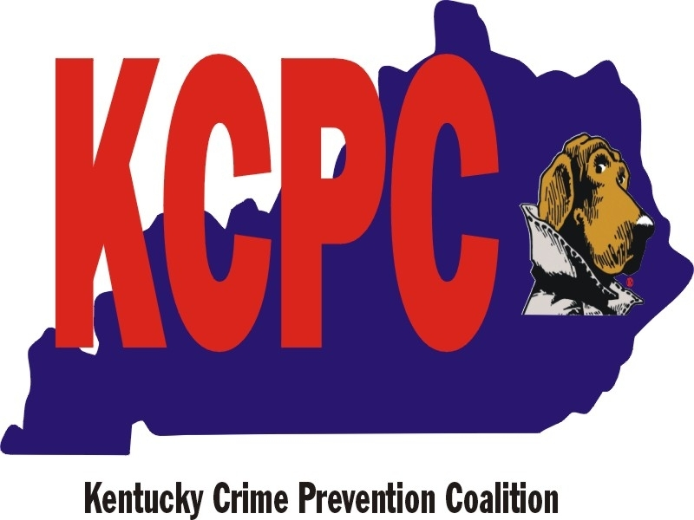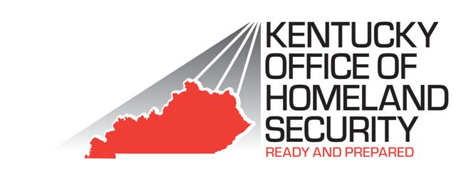

LEADERS NAME (LAST NAME, FIRST NAME | GROUP NAME
LEADER'S ADDRESS (INCLUDING ZIP CODE) | HOME PHONE NUMBER
DATE OF FIRST MEETING | WORK PHONE NUMBER
LAW ENFORCEMENT OFFICER | LAW ENFORCEMENT AGENCY

Members Names | Address | Email | Phone #
Use Additional Sheets if Necessary

